

**Spring Boot Learning Roadmap Analysis**

Yes, I can understand this PDF perfectly. This is a **Spring Boot learning roadmap** from [roadmap.sh](http://roadmap.sh) that provides a comprehensive guide for mastering Spring Boot and related technologies.

**Document Overview**

This roadmap document outlines a structured learning path for Spring Boot development, covering **40+ key topics** organized into **9 major technology areas**. It's designed to guide developers from foundational Spring concepts through advanced microservices architecture.

**Core Learning Sections**

**Spring Core Foundation**

The roadmap begins with fundamental Spring concepts including:

* Introduction and terminology
* Spring architecture principles
* Dependency injection and Inversion of Control (IoC)
* Aspect-Oriented Programming (AOP)
* Configuration management
* Bean scopes and annotations

**Spring Boot Essentials**

Focuses on Spring Boot-specific features:

* **Spring Boot Starters** - Pre-configured dependency bundles
* **Autoconfiguration** - Automatic application setup
* **Actuators** - Production-ready monitoring and management
* **Embedded Server** - Built-in web server capabilities

**Security Implementation**

Comprehensive security coverage including:

* Authentication and authorization mechanisms
* OAuth2 protocol implementation
* JWT (JSON Web Token) authentication
* Spring Security framework integration

**Data Management Technologies**

**Hibernate ORM**

* Transaction management
* Entity relationships and mapping
* Entity lifecycle understanding

**Spring Data Framework**

* **Spring Data JPA** - Java Persistence API integration
* **Spring Data MongoDB** - NoSQL database support
* **Spring Data JDBC** - Simplified database access

**Web Development with Spring MVC**

Traditional web application development covering:

* Servlet fundamentals
* JSP file handling
* MVC architecture patterns
* Component-based development

**Microservices Architecture**

Advanced distributed system concepts:

* **Spring Cloud** ecosystem
* **Spring Cloud Gateway** - API gateway implementation
* **Cloud Config** - Centralized configuration management
* **Circuit Breaker** patterns for resilience
* **OpenFeign** - Declarative REST clients
* **Hystrix** - Fault tolerance library
* **Sleuth** - Distributed tracing
* **Eureka** - Service discovery

**Testing Strategies**

Comprehensive testing approaches:

* JPA testing methodologies
* MockMVC for web layer testing
* @SpringBootTest annotation usage
* @MockBean annotation for mocking dependencies

**Learning Path Connections**

The roadmap strategically connects to broader learning tracks:

* **Java Roadmap** - Core programming language mastery
* **Backend Roadmap** - Overall backend development skills
* **DevOps Roadmap** - Deployment and operations knowledge

**Document Structure and Purpose**

This roadmap serves as a **visual learning guide** that helps developers:

1. **Understand prerequisite knowledge** (Java fundamentals)
2. **Follow a logical progression** from basic to advanced concepts
3. **Identify key technologies** in the Spring ecosystem
4. **Plan their learning journey** systematically
5. **Connect related technologies** and concepts

The document emphasizes practical, industry-relevant skills needed for modern Java backend development, particularly focusing on microservices architecture and cloud-native application development patterns.

⁂

**Complete Backend Java Developer Roadmap**

Based on the comprehensive analysis of all the roadmap PDFs you've shared, I've created a detailed **12-month learning path** that will take you from a complete beginner to an industry-ready Backend Java Developer. This roadmap combines the best practices from all the documents and is structured for optimal learning progression.

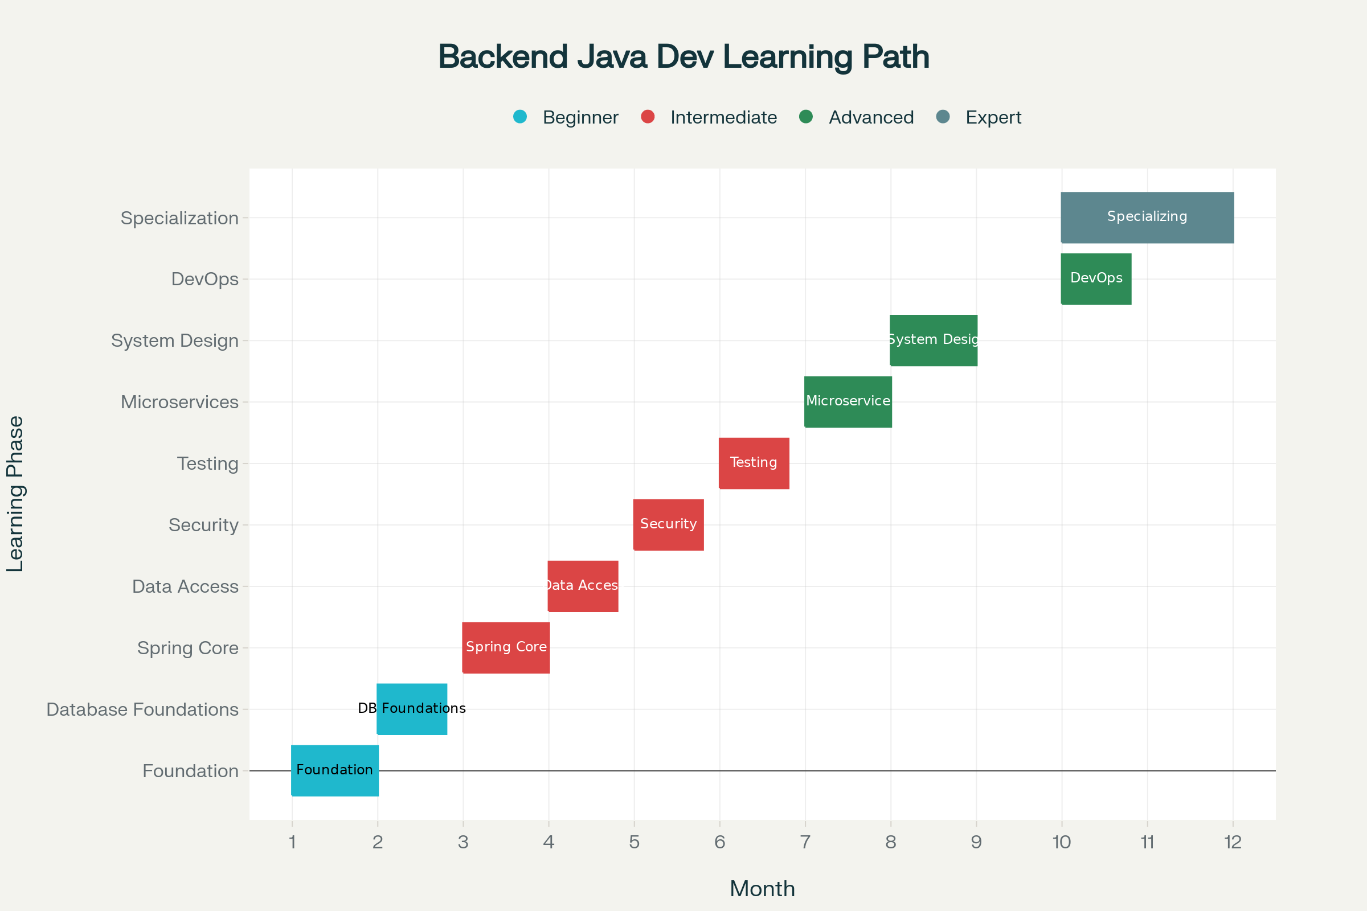

12-Month Backend Java Developer Learning Timeline

**Why This Roadmap Works**

This roadmap is meticulously designed based on the analysis of **7 different technical roadmaps** including backend development, Java specifics, Spring Boot, SQL, data structures, system design, and software engineering principles. Here's what makes it comprehensive:

**Key Strengths of This Roadmap**

**Progressive Learning Structure**: Each phase builds upon the previous one, ensuring solid foundations before advancing to complex topics.

**Industry-Relevant Technologies**: Focuses on the most demanded technologies in the Java ecosystem - Spring Boot, microservices, cloud technologies, and modern development practices.

**Practical Project Integration**: Includes 4 major projects throughout the journey, from basic CRUD applications to scalable microservices systems.

**Real-World Preparation**: Covers not just coding but also system design, DevOps practices, testing strategies, and performance optimization.

**Learning Philosophy**

The roadmap follows a **"Learn → Practice → Build → Scale"** approach:

* **Months 1-3**: Core fundamentals and basic application development
* **Months 4-6**: Intermediate concepts with security and testing
* **Months 7-9**: Advanced architecture patterns and microservices
* **Months 10-12**: Expert-level topics and specialization

**Assessment & Milestones**

Each phase includes specific **assessment milestones** to ensure you're ready to progress:

* **Month 2**: Build a basic REST API with database integration
* **Month 4**: Create a complete CRUD application with authentication
* **Month 6**: Develop a secure, well-tested web application
* **Month 8**: Implement a microservices architecture
* **Month 10**: Deploy a production-ready application with monitoring
* **Month 12**: Pass system design interviews and tackle complex problems

**Technology Stack Covered**

**Core Technologies**: Java 17+, Spring Boot 3.x, Spring Security, Spring Data JPA, Hibernate

**Databases**: PostgreSQL, MySQL, Redis, MongoDB basics

**Testing**: JUnit 5, Mockito, TestContainers, REST Assured

**DevOps**: Docker, Kubernetes basics, CI/CD pipelines, monitoring

**Architecture**: Microservices, REST APIs, gRPC, message queues, caching strategies

**Recommended Next Steps**

1. **Start with Phase 1** - Set up your development environment and begin with Java fundamentals
2. **Follow the project timeline** - Don't skip the practical projects as they reinforce learning
3. **Join communities** - Engage with Spring Boot and Java developer communities
4. **Practice coding problems** - Use LeetCode and HackerRank for algorithmic thinking
5. **Build a portfolio** - Document your projects on GitHub with proper README files

**Additional Resources You Might Need**

If you have additional roadmap PDFs covering **Cloud Technologies (AWS, Azure, GCP)**, **Advanced Docker/Kubernetes**, or **Specific Industry Domains (Fintech, E-commerce)**, please share them. These could help me create specialized extensions to this roadmap based on your target industry or preferred cloud platform.

This roadmap provides a solid foundation for becoming a competent Backend Java Developer. The key to success is consistent daily practice, building real projects, and gradually increasing complexity as you progress through each phase.

⁂

**Detailed Backend Java Developer Roadmap: Phase-by-Phase Breakdown**

**This guide details all the must-cover topics for each phase of your 12-month backend Java developer journey. It’s organized for efficient self-study and mastery of essential skills, directly referencing content from your shared PDFs and the broader current industry landscape.**

**Phase 1: Foundation (Months 1-2)**

***Core Java & OOP***

|  |  |
| --- | --- |
| Area | Topics to Cover |
| Java Basics | Syntax, data types, variables & scopes, operators, conditionals (if, switch), loops, type casting, arrays, strings & methods, math operations, lifecycle of program [10][11] |
| OOP Concepts | Classes & objects, attributes & methods, access specifiers, static/nested classes, inheritance, polymorphism, abstraction, encapsulation, interfaces, enums, record |
| Advanced OOP | Method overloading/overriding, static vs dynamic binding, lambda expressions, functional interfaces, annotations, packages, modules, initializer blocks, pass by value/reference [10][11] |
| Collections | List, Set, Map, Queue, Stack, Dequeue, Iterator, Array vs ArrayList, generic collections, Optionals [10][11] |
| Exception Handling | Try-catch-finally, custom exceptions, best practices |
| Build Tools | Maven, Gradle, Bazel (how to build/run/test/manage dependencies) [10] |
| IDE & Git | IDE setup (IntelliJ/Eclipse), Git fundamentals, workflow, version control, repo hosting (GitHub/GitLab/Bitbucket) [12][10][11] |

**Phase 2: Database Foundations (Month 2)**

***Relational and NoSQL Basics, Essential SQL***

|  |  |
| --- | --- |
| Area | Topics to Cover |
| SQL Syntax | SELECT, INSERT, UPDATE, DELETE, WHERE, GROUP BY, ORDER BY, HAVING [13][11] |
| Joins | INNER, LEFT, RIGHT, FULL OUTER, CROSS, SELF, subqueries (scalar/column/row/table) |
| Advanced SQL | Aggregate functions (SUM, COUNT, AVG, MIN, MAX), window functions, CTEs, indexes, constraints, performance queries |
| Database Design | Normalization (1NF/2NF/3NF), ACID, transactions (begin/commit/rollback), isolation, primary/foreign keys, DDL/DML/DCL, CRUD [13][11] |
| Database Tech | PostgreSQL, MySQL (focus), JDBC integration, schema design |
| NoSQL | Concepts, when to use, types: document (MongoDB), key-value (Redis), CAP theorem basics [12][11] |
| ORM | JPA, Hibernate (mapping, entities, relationships, persistence) [10][14][11] |

**Phase 3: Spring Framework Core (Months 3-4)**

***Spring, DI, AOP, MVC, Core Boot Concepts***

|  |  |
| --- | --- |
| Area | Topics to Cover |
| Spring Core | IoC, Dependency Injection (constructor/setter/field), bean lifecycle, Spring configuration (XML/Java/Annotation) [14] |
| Spring AOP | Aspect-oriented concepts, advice, pointcuts, cross-cutting concerns |
| Boot Project | Spring Boot starters, auto-configuration, application.properties, loggers, environment profiles |
| Embedded Server | Tomcat/Jetty basics, running standalone jars [14] |
| Spring MVC | Controllers, REST endpoints, Mapping, Request/Response, validation, exception handling, static files |
| REST APIs | JSON/XML serialization, HTTP status, API documentation (Swagger/OpenAPI) |
| Testing Setup | JUnit, @SpringBootTest, testing strategies [10][14] |

**Phase 4: Data Access & Persistence (Month 4)**

***Spring Data, JPA & Hibernate Advanced, Transactional Apps***

|  |  |
| --- | --- |
| Area | Topics to Cover |
| Spring Data JPA | Repositories, CRUD, custom queries, pagination, sorting, specifications, projections [14] |
| Hibernate | Entity relationships (OneToOne, OneToMany, ManyToOne, ManyToMany), fetch types, cascades |
| Entity Lifecycle | @Entity, @Table, @Id, EntityManager usage, persistence context |
| Transactions | ACID in Spring, @Transactional, isolation levels, rollback, savepoints |
| Performance Tuning | N+1 problem, Lazy vs Eager loading, caching, profiling |
| Database Integration | Multiple data sources, migrations (Flyway, Liquibase) |

**Phase 5: Security & Authentication (Month 5)**

***Secure Java Apps with Spring Security***

|  |  |
| --- | --- |
| Area | Topics to Cover |
| Authentication | Basic/Form, JWT, OAuth2, session vs token vs cookie, SAML, OpenID [12][14] |
| Authorization | Roles, permissions, method-level, URL security |
| Advanced Security | CSRF, CORS, HTTPS/SSL/TLS, password hashing (bcrypt, scrypt), server security |
| Security Coding | Spring Security config, custom user details, password encoders, integrating social logins |
| API Security | Secure endpoints, best practices, API key management, OAuth flows [12][14] |
| Security Testing | Vulnerability scans, penetration testing, reviewing OWASP top 10 |

**Phase 6: Testing (Month 6)**

***Comprehensive Java & Spring Testing***

|  |  |
| --- | --- |
| Area | Topics to Cover |
| Unit Testing | JUnit (5+), assertions, parameterized tests |
| Mocking | Mockito, @Mock, @MockBean, stubbing, spying |
| Integration Testing | Spring Boot integration (@SpringBootTest), TestContainers, database testing |
| Web/API Testing | MockMVC for controllers, REST Assured, Postman test suites |
| Test Automation | Test reporting, CI/CD integration, code coverage, static analysis |
| Behavior/Performance | Cucumber, JMeter, load tests |

**Phase 7: Microservices & Advanced Topics (Months 7-8)**

***Building Real Microservices with Spring and Cloud Tech***

|  |  |
| --- | --- |
| Area | Topics to Cover |
| Microservices Concepts | Principles & benefits, comparison to monolith, domain-driven design, twelve-factor app [12][14] |
| Service Discovery | Eureka, Consul [14] |
| API Gateway | Spring Cloud Gateway, route mapping, filters [14] |
| Distributed Config | Spring Cloud Config, central config server |
| Circuit Breakers | Resilience (Hystrix, Resilience4j), fallback logic, bulkheads |
| Messaging | RabbitMQ, Kafka (basics, publishing/consuming events) [12][14] |
| Tracing/Observability | Sleuth, Zipkin, distributed logging/tracing basics |
| Docker | Images, containers, networking, volumes, Docker Compose |
| CI/CD | Pipeline design, Jenkins/GitHub Actions for microservices |

**Phase 8: System Design & Architecture (Months 8-9)**

***Designing and Scaling Large Backend Systems***

|  |  |
| --- | --- |
| Area | Topics to Cover |
| Scalability | Horizontal vs vertical scaling, load balancers (Nginx, HAProxy), caching (Redis/Memcached) |
| High Availability | Replication, sharding, failover, master/slave |
| CAP Theorem | Understanding trade-offs, consistency/availability/partition tolerance [12][15] |
| Messaging Patterns | Event-driven, async processing, message queues (RabbitMQ, Kafka), pub-sub models |
| Design Patterns | Singleton, Factory, Observer, Strategy, Command, Repository, CQRS, Event Sourcing [12][15] |
| Architecture | Monolith vs microservices, SOA, DDD, Clean Architecture, layered architecture |
| System Design Scenarios | Estimate scale, API rate limiting, graceful degradation, throttling, circuit breakers |

**Phase 9: DevOps & Production (Month 10)**

***Deploying, Monitoring, and Running Java Apps in Production***

|  |  |
| --- | --- |
| Area | Topics to Cover |
| Version Control | Git workflow, branching, PRs, code reviews, CI/CD best practices [12][11] |
| Containers & Infra | Docker orchestration (Compose, Swarm), Kubernetes basics (pods, services), Helm |
| Deployment | Automated builds, rolling updates, blue-green/canary deploy, config management |
| Monitoring | App monitoring (Actuator, Prometheus, Grafana), log aggregation, metrics |
| Alerts & Telemetry | Application and infra metrics, setting up alert systems, health checks |
| Security Monitoring | Reviewing logs for security, SIEM basics |
| Performance Analysis | Profiling (JVisualVM, YourKit), JVM tuning, memory/leak analysis, GC logs |

**Phase 10: Advanced Topics & Specialization (Months 10-12)**

***Mastery and Niche Technologies***

|  |  |
| --- | --- |
| Area | Topics to Cover |
| Concurrency | Java threads, virtual threads, thread pool, concurrent collections, locks, memory model |
| JVM Internals | Tuning, garbage collection, performance optimization |
| NoSQL & Search | MongoDB (CRUD, queries, indexes), Neo4j (graph basics), Elasticsearch, Solr |
| Real-time Systems | WebSockets, Server Sent Events, polling strategies, InfluxDB, Cassandra basics |
| Event-Driven Systems | Kafka advanced (streams, partitions, consumer groups), event sourcing patterns |
| Project Portfolio | Showcase 3+ finished backend projects on GitHub, with documentation and API specifications |
| System Design Interviews | Practice design scenarios, prepare for DSA and system design interview questions |

**Project Guidance at Each Stage:**

|  |  |
| --- | --- |
| Phase | Example Project |
| Foundations | CLI/book management app, CRUD with basic Java & MySQL |
| Spring Core | Simple REST API (TODO app) with Spring Boot & database |
| Data Layer | Blog platform with Hibernate/Spring Data (users, posts, comments) |
| Security/Testing | User authentication system (JWT/OAuth2), tested endpoints |
| Microservices | Ecommerce + order management with Spring Cloud + Docker |
| System Design | Medium + notification service with robust scaling, caching, tracing |
| Production/DevOps | Deploy above apps to cloud (AWS/GCP), containerized, CI/CD pipelines |
| Specialization | Real-time chat app, search API, event-driven notification microservice |

**Additional Advice**

* **Use LeetCode, Edabit, HackerRank** to brush up DSA ().[16][11]
* **Make sure all code is versioned, tested, and shared** (GitHub).
* **Follow official documentation** especially Java ([oracle.com](http://oracle.com)), Spring ([spring.io](http://spring.io)), and relevant database docs.
* **Build real-world projects** to consolidate your understanding.
* **Always prepare for system design and behavioral interview questions** for top jobs.

**This level of detail ensures you become a well-rounded backend engineer with top-notch proficiency in Java and Spring Boot. If you want topic-by-topic resources or week-by-week breakdowns for each phase, let me know!**

⁂

1. spring-boot.pdf

1. backend.pdf

1. java.pdf

1. spring-boot.pdf

1. sql.pdf

1. datastructures-and-algorithms.pdf

1. SDE-Roadmap.pdf

1. system-design.pdf

1. <https://ppl-ai-code-interpreter-files.s3.amazonaws.com/web/direct-files/ca8c0bd7620c7319e7d44fce1b727595/27e53191-bbab-451b-b9e5-cc3a5cd16c8c/ad28ec11.md>

1. java.pdf

1. SDE-Roadmap.pdf

1. backend.pdf

1. sql.pdf

1. spring-boot.pdf

1. system-design.pdf

1. datastructures-and-algorithms.pdf